Hi Guys: This is the required structure to our final report. Please, drop here all the information that you think can be useful to defend our project. Everything is welcome, even if you are not sure. Just drop information here in this document, since it will be the input to adjust a final version.

Notice that some points are more clear than other ones. For example, the test part of our software, is not at all clear and we can have many suggestions. At the end, we will conciliate one that works for all the three clients.

1. Introduction

* Context of the word: e.g. A one to one chat system with security connection…
* What we have achieved: (a briefly summary).

1. Review

* Describe related work: e.g. (other systems or models we used or that we use to “inspired” us).
* Describe Firebase (pros and contras) as well as other options

1. Requirements and Designs

* Describe our final selections: e.g. We use Fire base and why. So, for example, why we prefer to use firebase instead of sockets, or whatever…
* Selected requirements: e.g. 3 clients, security connection, etc.
* Design of the application

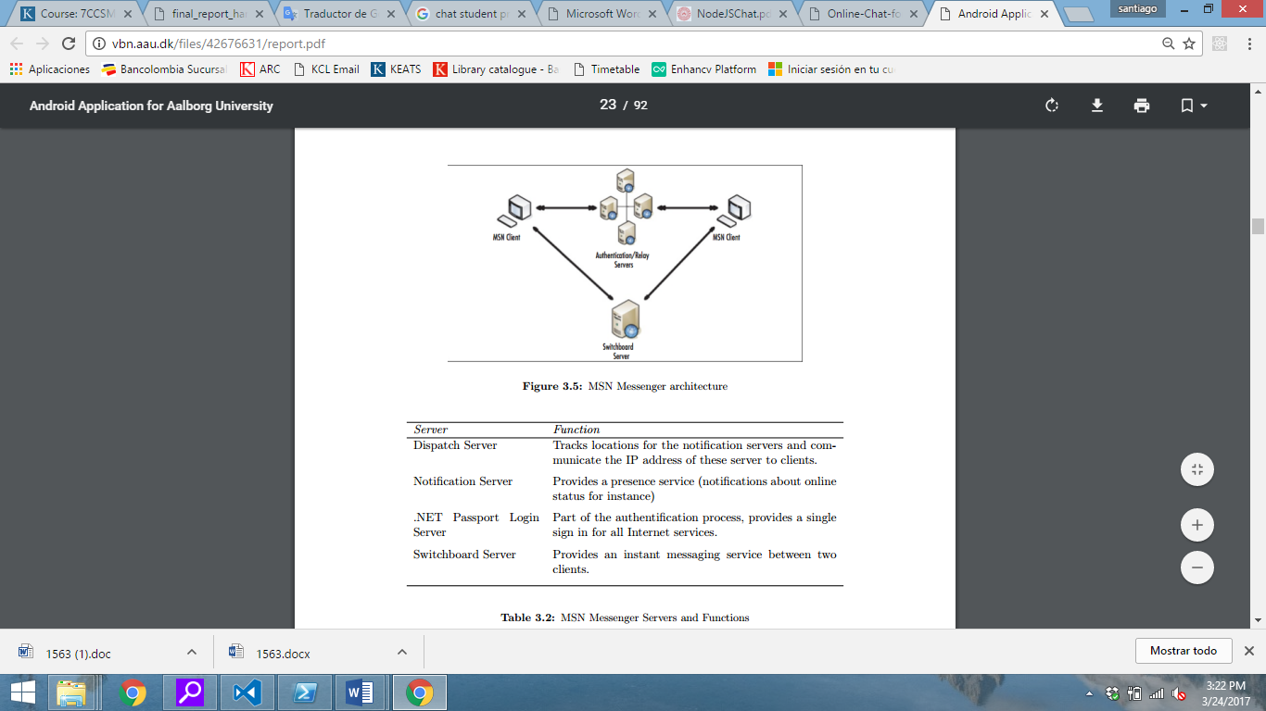

Example

* + Clients / Backend
  + Connections
  + Data base structure

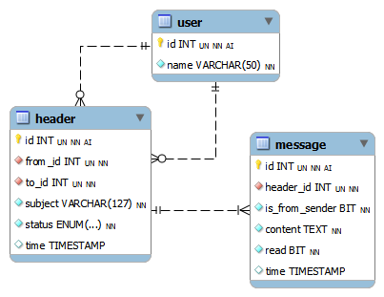

Example

1. Implementation

* Descriptions of significant details of our project (e.g. security connections, etc.)
  + Quote of code fragments where it is considered necessary
* Test of our software

(Please think in some ways to test our software. E.g., connections, that if we create a new conversation with the same person we recover the last chat without creating a new one, or things like that).

1. Team work

* How we worked together? Tools, and process we use to facilitate our work as a team…

(Basically, the same of our first report…)

* Additionally, we can include more information of how we use GitHub and our learning process with this tool.

1. Evaluation

* Self-evaluation of our team: i) what worked well and ii) what didn’t work well

E.g. Trying to synchronize agendas was a difficult point, since everybody have multiple and different duties.

* How we do relative to our initial plan (we have just to compare with our initial schedule and adjust little be to make it coincide with GitHub advances).

We have can also justified why our plan change, as well our times. It doesn’t matter that our plan is different of our final execution, whenever we justified things. For example, we can mention that make an extra revision if using firebase would be our final approach, based on the feedback of the first report.

* What we change during the project and why?

E.g. we can discuss a little bit more here, why we decide to continue with Firebase.

* Weakness and strengths of our team

E.g. The diversity of professions in our team, despite can be consider as a strength to formulate new thinks and approach problems with other perspectives, for this specific project was also a weakness since the software programing required level was high. Thus, the majority of the members were learning and trying to implement at the same time.

E.g. communication process.

* Future work that can be implemented in our work (the other features). This part, is like our next step, which I guess also must be a differential.

E.g. Include a survey of how well a person chats, so everybody can receive a feedback and improve their behaviors based on that. Also, that would be useful to mining the data and discover parameters or patterns that contribute to create a friendlier and efficiently chat community.

1. Peer Assessment

Laurence request here just the table with the mark distribution.

1. References

If you have any suggested reference or source, we can quote…

1. Appendix